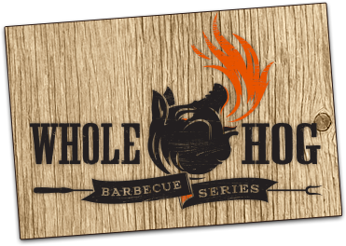
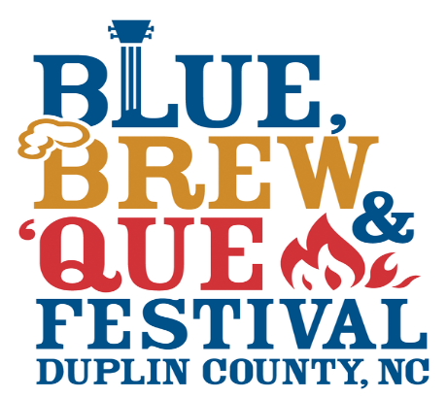

Barbecue Cook Off
Awards
1st Place $500 & Trophy
2nd Place $300 & Trophy
3rd Place $200 & Trophy
Showmanship Award

OFFICIAL RULES AND REGULATIONS FOR BLUE, BREW, & QUE COOK-OFF MARCH 30TH 2019
1. The Chief Cook will be responsible for the conduct of his/her team or guest(s).
2. No outside alcoholic beverages will be allowed on the grounds (alcohol will be available at festival)
3. A copy of these rules, score sheet and parking permits will be mailed to each Chief Cook prior to the contest.
4. All cooking spaces will be numbered and each will measure 12’X20’.
5. Contestants are expected to respect the rights of other contestants with special emphasis on loud music, loud or profane language or infringement of adjoining site with equipment, cars, cookers or campers.
6. Contestants may not sell any food, drinks or any other items to the public.
7. Each cooking space will be given one vehicle parking permit due to limited space.
8. Parking permits will be displayed in the upper left hand corner of the auto windshield.
A representative of the cook off Committee will direct you to the proper site.
9. No campers will be parked directly on the cooking site; all campers must park on the outside of fence. Campers will not be allowed to connect to site electricity.
10. Roads must be kept clear of any obstruction so emergency vehicles, meat truck or any other
maintenance vehicles can pass through.
11. Pigs will be cooked in an “above ground cooker”; all cookers will be approved. No wooden box cookers will be allowed.
12. Drip pans for grease will be used on all cookers.
a. All grease is to be emptied into the buckets provided at the rear of the chopping tent.
b. No charcoal or wood embers are to be emptied on the grounds.
13. If you are cooking with wood or making your own charcoal you will need to provide your own burn barrel. THE FESTIVAL WILL NOT PROVIDE ANY BURN BARRELS! Open fires will be allowed only for the purpose of making coals for cooking your pig. Please keep fires as low as possible. All fire barrels must have a safety area so as to keep the unwary from stumbling into them.
14. Each gas cooker will be required to meet safety standards.
A Representative of the Contest and the Fire Marshall will inspect all gas cookers for the following items:
1. Gas leaks (from tanks and burners)
2. Solid connections (all hoses must be L P gas hoses. Quick connects will be considered solid connections).
3. Tanks will be secured in or to something to prevent them from being turned over (i.e., to a post or in a milk crate).
4. Fire extinguishers will be required on all cookers for safety reasons.
5. All cooking tents will be required to meet the following safety standards;
CPAI 84: CPAI 84 is a test method written by the Industrial Fabrics Association International for
Flame-resistant materials used in camping tents.
The definition of camping tent is “any portable temporary shelter or structure
designed to protect people from the elements” and includes such products as
Camping tents ‘play tents, and ice fishing tents.

BEFORE A COOK CAN RECEIVE HIS/HER PIG, HE/SHE MUST PASS THIS INSPECTION;
* THIS RULE IS MANDATORY AND SHALL BE HEEDED BY ALL GAS COOKERS
1. If your burner goes out, immediately shut off gas.
2. Open all doors and lids on your cooker.
3. Wait no less than two (2) minutes before attempting to relight your burner. Leave lid open while relighting.
15. Each Chief Cook is to have the following utensils on hand for judging:
(A) Four sharp knives
(B) Four cups of water
(C) Towels (paper or cloth)
(D) Four sauce bowls
(E) Hand Washing Station (with water, soap, hand sanitizer, paper towels and a container to catch gray water).
16. Site number will be drawn at the Chief Cooks’ meeting to determine where the judging will begin.
A. All Pigs will be delivered at 8:00 p.m. after the Chief Cooks meeting. (Cooks may begin cooking at any time).
B. Judging will begin at 8:00 A.M. Saturday morning at the site that was chosen during the drawing.
17. Cookers order of judging:
A. The first site to be available for judging at 8:00 A.M. will be determined by a drawing at the Cook’s meeting.
B. There will be no passes. Cooks will be given enough time to complete their pig. If the cook is not ready for judging he/she will be disqualified.
18. No trophies or awards will be on display between 8:00 A.M. and the completion of all judging.
19. A representative of the judging committee will:
A. Accompany judges while pigs are being judged and take up score sheets.
B. Know exclusively the person who will present the pig for judging on each site.
C. See that only one person representing the Cook-Sponsor is present at the cooker while his/her pig is being judged.
20. If and when the Chief Cook decides to withdraw or disqualifies his/her pig from competition, he/she will notify the Committee as soon as possible.
21. No pigs will be removed from the cooking site under any circumstances.
22. Any pig will be disqualified if any part of the pig is removed or intentionally disturbed other than cutting that which is allowed for the purpose of preparation.
A. PIGS SHOULD NOT BE SAUCED INSIDE OR OUTSIDE. SAUCED PIGS WILL BE DISQUALIFIED.
B. NO EXTERNAL HEAT SOURCES MAY BE USED OTHER THAN THE GRILL. SOME EXAMPLES ARE BUT ARE NOT LIMITED TO: (HEAT GUNS, TORCHES). THOSE USING EXTERNAL HEAT SOURCES WILL BE DISQUALIFIED.
C. INJECTING PIGS WILL NOT BE ALLOWED. EXAMPLES INCLUDE BUT ARE NOT LIMITED TO (SAUCE, OILS, PRODUCT DRIPPINGS). THOSE INJECTING WILL BE DISQUALIFIED.
23. Any pigs judged “Not done” will be disqualified. Cooks are required to continue cooking the pig until, in the opinion of the Committee, the pig is done.
24. Each judge will be given score sheets with no information which would in any manner identify the Cook-Sponsor. The committee, not the judges, will total and grand total the score sheets.
25. Each team is responsible for de-boning their pig before turning it over to the committee to be chopped.
26. A completed score sheet with your average score in each category will be available for each entry after the awards ceremony has been completed. Score sheets will not be mailed out.
27. In the event of a tie, tied positions will be determined by the committee based on the team with the highest score on “Meat and Sauce Taste.” If there is a tie in that category as well, the tie will be broken based on the team with the highest score for “Skin Crispiness.”
28. Contest winners will be announced at 11:00 a.m. on Saturday morning.
29. No prize money will be donated to any organization during the Award ceremony.
30. No Sponsor signs will be removed from the cooking site.
31. THE COMMITTEE RESERVES THE RIGHT TO MAKE ADDITIONAL RULES AND
REGULATIONS AS THE SITUATION WARRANTS.
32. Violations of the Rules and Regulations of the contest may result in disqualification.
33. The Committee reserves the right to accept or reject any participant.
34. The Blue, Brew, & Que Festival, Blue, Brew, & Que Committee, The Events Center, Events Center Sub Committee Board, Duplin County Board of Commissioners, Duplin County Agri-Community Foundation and Duplin County are not responsible for damaged, lost or stolen items or accidents.
All property of the teams shall be under the care, custody and control of the team, whether in transit to or from or within the cook-off site.
35. Decisions of the Committee and Judges are final.
36. PLEASE NOTE: NO PETS!

